**Indian Institute of Technology, Indore**

**CS 257**

**DBIS Project**

**Online Retail Portal**

Submitted by- Anurag Verma (160001005)

**Project Description:**

The aim of the project is to create an efficient online college student portal (a.k.a online College student records) which facilitates the students of the college to keep track of their academic, courses, personal, money transactions etc. records online. The website would provide a student interface for students to login to through credentials provided by the college administration and a admin interface for registration of new students.

**ER Analysis: Identifying Entity Sets and Relationship Sets**

1. Central Entity Set:
2. Student(E)
3. RollNo
4. FirstName
5. LastName
6. Program
7. Department
8. BatchYear
9. Username
10. Password
11. Entity-Relation for Academic Information:
12. Student(E)

Attributes same as before

1. Academics(E)
2. RollNo
3. Year
4. Semester
5. SPI
6. CPI
7. Records(R)
8. Entity-Relation for Courses’ Information:
9. Student(E)

Attributes same as before

1. Courses(E)
2. RollNo
3. CourseCode
4. CourseName
5. Type
6. Semester
7. Grade
8. Status
9. Currently Registered(R)
10. Entity-Relation for Medical Information:
11. Student(E)

Attributes are same as before

1. Biodata(E)
2. RollNo
3. FirstName
4. LastName
5. Gender
6. DOB
7. Age
8. BirthMark
9. Bloo_Gp
10. Height
11. Weight
12. Medical Info(R)
13. Entity-Relation for Personal Information:
14. Student

Attributes same as before

1. Personal_Info
2. RollNo
3. FirstName
4. LastName
5. Mob_No
6. Address
7. General Info(R)
8. Entity-Relation for Money Transaction Information:
9. Student(E)

Attributes same as before

1. Fees(E)
2. Transaction_Id
3. RollNo
4. Date
5. Time
6. Amount
7. Method
8. Payment(R)

**ER Diagrams**

1. For Acadmics

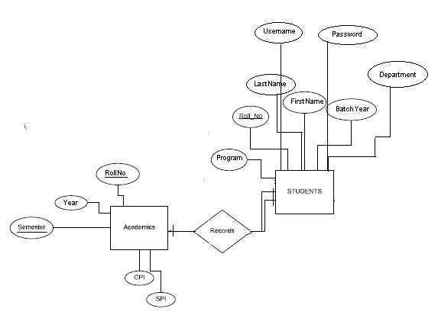

1. For Courses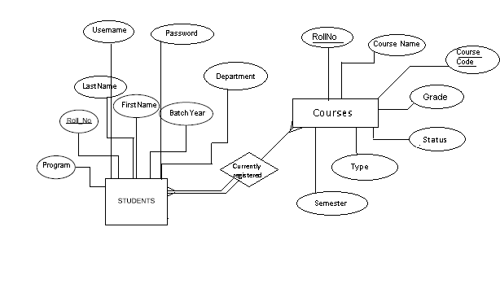
2. For Biodata

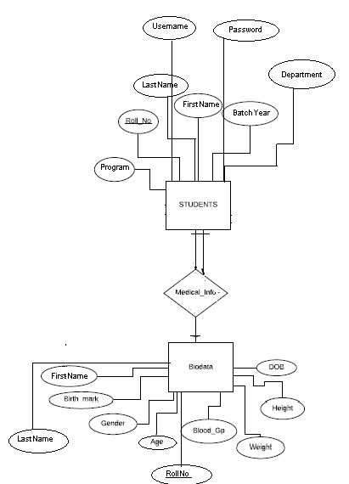

1. For Personal_Info

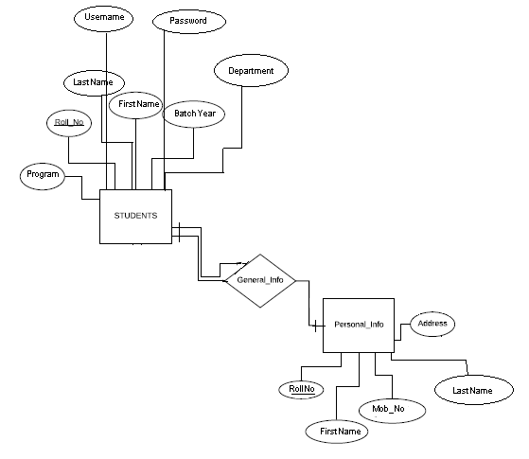

1. For Fees

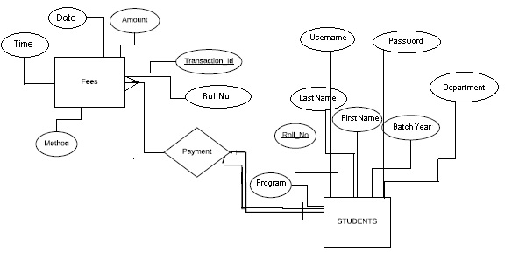

**ER Diagram for whole College Student Portal:**

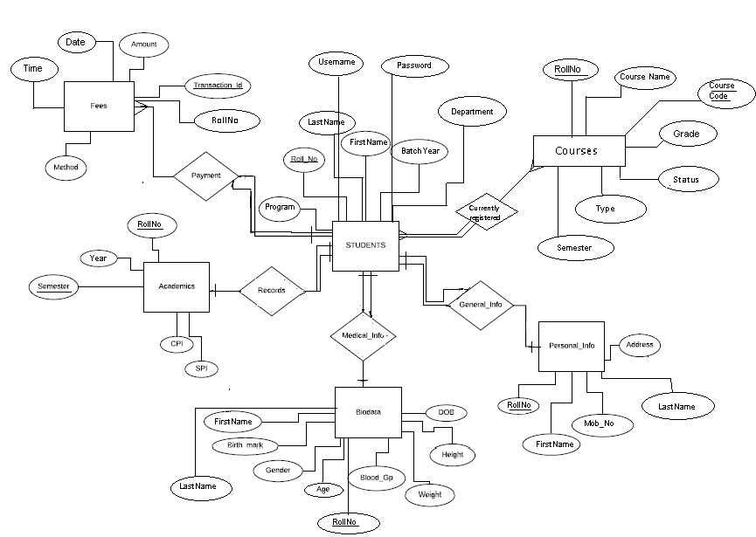

**Transformation of ER Diagram into set of tables:**

1. **Student**

CREATE TABLE `student` (

`RollNo` int(11) NOT NULL,

`FirstName` varchar(25) NOT NULL,

`LastName` varchar(25) NOT NULL,

`Program` varchar(45) NOT NULL,

`Department` varchar(25) NOT NULL,

`BatchYear` int(11) NOT NULL,

`Email` varchar(255) NOT NULL,

`Username` varchar(15) NOT NULL,

`Password` varchar(255) NOT NULL,

PRIMARY KEY (`RollNo`)

) ENGINE=InnoDB DEFAULT CHARSET=utf8;

1. **Academics**

CREATE TABLE `academics` (

`RollNo` int(11) NOT NULL,

`Semester` int(11) NOT NULL,

`Year` int(11) NOT NULL,

`SPI` int(11) DEFAULT NULL,

`CPI` int(11) DEFAULT NULL,

PRIMARY KEY (`RollNo`,`Semester`)

) ENGINE=InnoDB DEFAULT CHARSET=utf8;

1. **Courses**

CREATE TABLE `courses` (

`RollNo` int(11) NOT NULL,

`Course Name` varchar(20) NOT NULL,

`Course Code` varchar(45) NOT NULL,

`Type` enum('C','E') NOT NULL,

`Semester` int(11) NOT NULL,

`Grade` char(1) DEFAULT NULL,

`Status` enum('P','F') DEFAULT NULL,

PRIMARY KEY (`RollNo`,`Course Code`)

) ENGINE=InnoDB DEFAULT CHARSET=utf8;

1. **Biodata**

CREATE TABLE `biodata` (

`RollNo` int(11) NOT NULL,

`FirstName` varchar(25) DEFAULT NULL,

`LastName` varchar(25) DEFAULT NULL,

`Birthmark` varchar(55) DEFAULT NULL,

`Gender` enum('M','F') DEFAULT NULL,

`DOB` varchar(25) DEFAULT NULL,

`Age` int(11) DEFAULT NULL,

`Blood_Gp` varchar(3) DEFAULT NULL,

`Height` int(11) DEFAULT NULL,

`Weight` int(11) DEFAULT NULL,

PRIMARY KEY (`RollNo`)

) ENGINE=InnoDB DEFAULT CHARSET=utf8;

1. **Personal_Info**

CREATE TABLE `personal_info` (

`RollNo` int(11) NOT NULL,

`FirstName` varchar(25) NOT NULL,

`LastName` varchar(45) NOT NULL,

`Mob_No` char(10) NOT NULL,

`Address` varchar(50) NOT NULL,

PRIMARY KEY (`RollNo`)

) ENGINE=InnoDB DEFAULT CHARSET=utf8;

1. **Fees**

CREATE TABLE `fees` (

`Transaction_Id` int(11) NOT NULL,

`RollNo` int(11) NOT NULL,

`Date` date NOT NULL,

`Time` time NOT NULL,

`Amount` int(11) NOT NULL,

`Method` varchar(30) NOT NULL,

PRIMARY KEY (`Transaction_Id`,`RollNo`)

) ENGINE=InnoDB DEFAULT CHARSET=utf8;

**Triggers:**

1. **deletestudent**

CREATE DEFINER=`root`@`localhost` TRIGGER deletestudent

before delete ON student

FOR EACH ROW

BEGIN

delete from academics where academics.RollNo=old.RollNo;

delete from personal_info where personal_info.RollNo=old.RollNo;

delete from biodata where biodata.RollNo=old.RollNo;

delete from fees where fees.RollNo=old.RollNo;

delete from courses where courses.RollNo=old.RollNo;

END

1. **UpdateCourseStatus**

CREATE DEFINER=`root`@`localhost` TRIGGER UpdateCourseStatus

before UPDATE ON courses

FOR EACH ROW

BEGIN

If(new.Grade>"E") then

set new.status="F";

elseif(new.Grade<"F") then

set new.status="P";

else

set new.status=NULL;

END if;

end

**Constraints:**

1. To check valid information in forms.
2. To check if the username for student account is already taken.
3. Only Admin can Add a new student.
4. Students can only view their Information stored in college database. For any correction they must contact the college administrations

**Features and Functions of the College Student Portal:**

1. Student Login:

In order to keep track of their records stored in the college database the students will be given a set of username and password at the time of registration which will allow them to log in to the college student portal. If the given credentials doesn’t work then they will have to contact the college administration asap as this is one of the most vital information

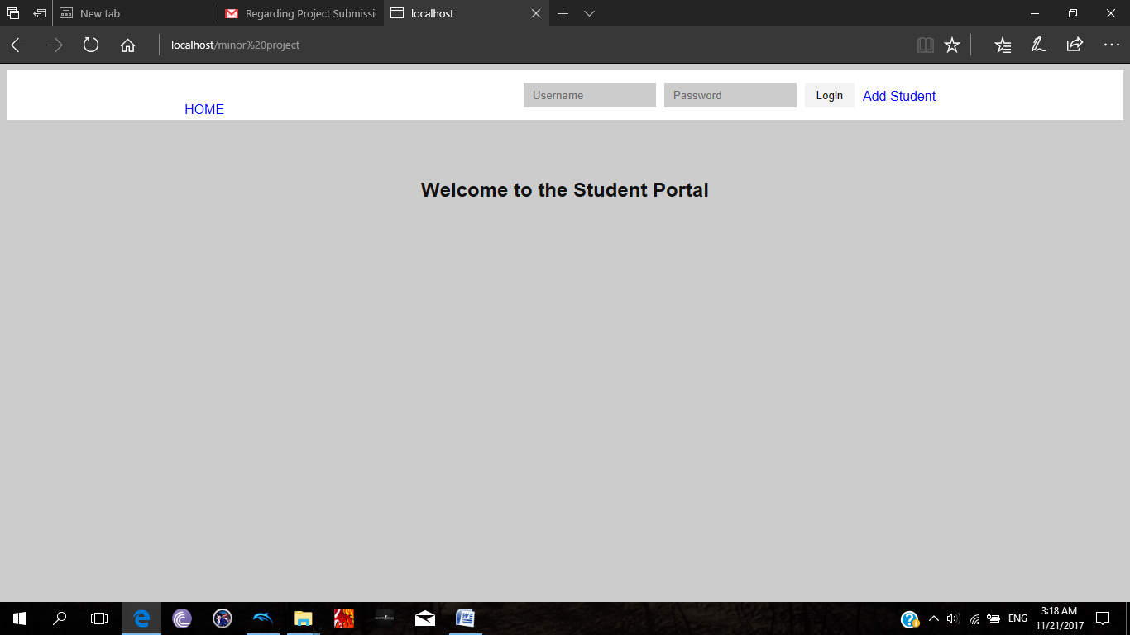 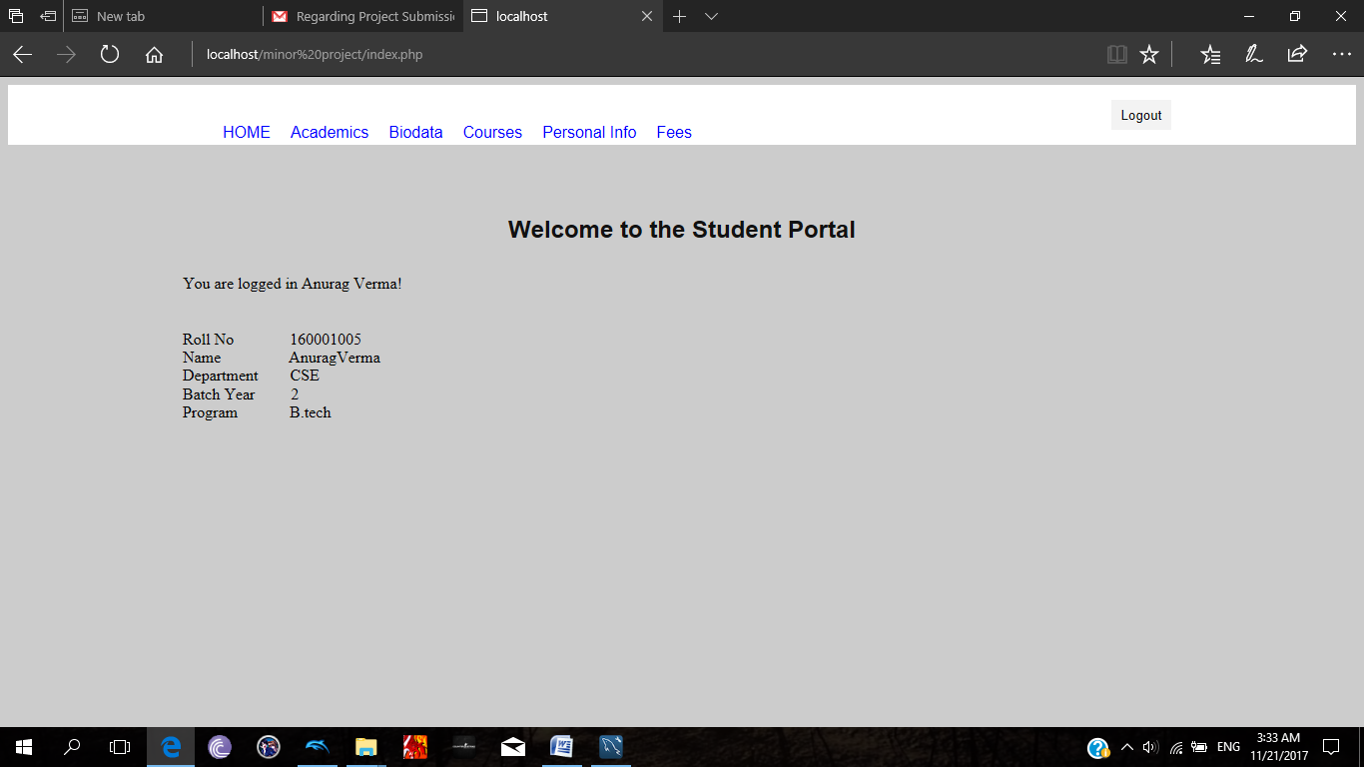.

1. Viewing Academic Information:

The students can see their progress in the program they are registered for here. Their SPI and CPI will be displayed along with the grades they obtained in the various courses. For any correction in the records they will have to contact the college administration.

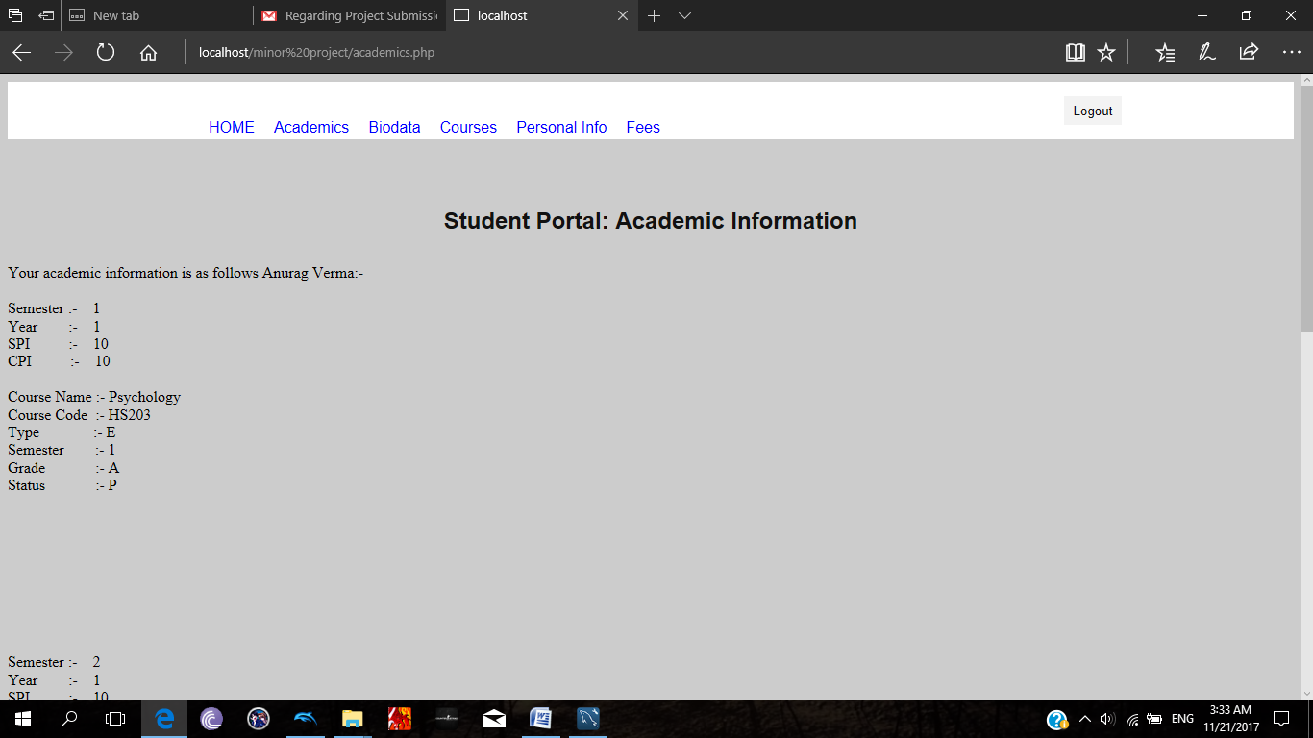

1. Viewing Courses’ Information:

The students can see the various courses that they have registered in the current semester. For any correction/changes they will have to contact the college administration.

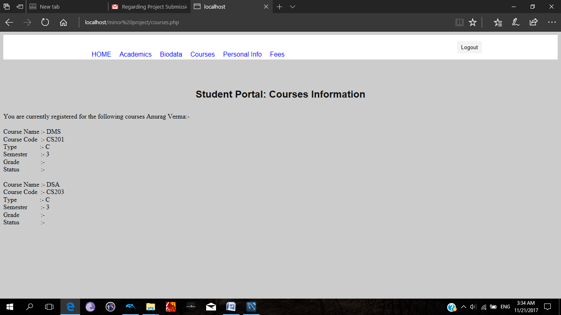

1. Viewing their Biodata:

The students can see their biodata here which will be updated as per regular physical checkups during each year. For any correction/changes they will have to contact the college administration.

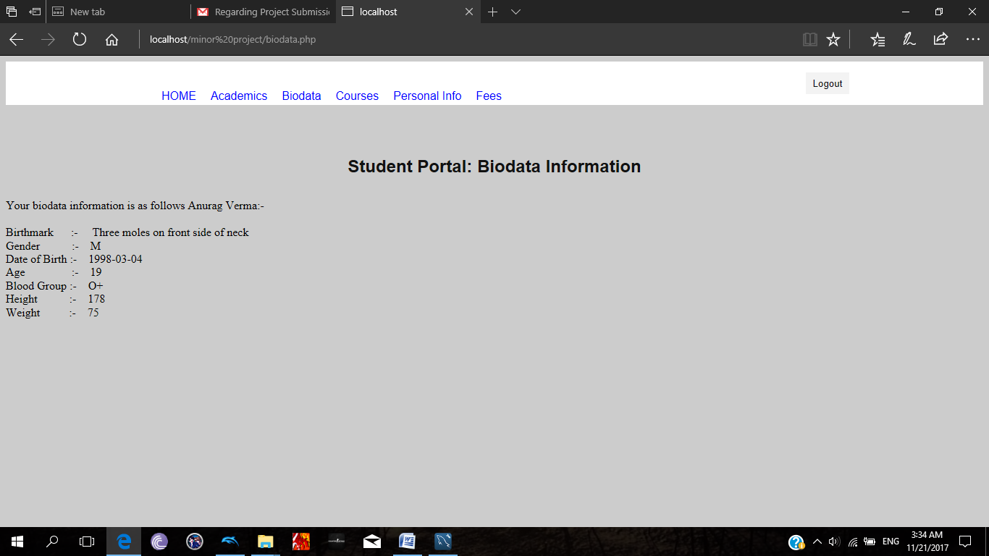

1. Viewing Personal Information:

The students can see their personal contact information here. This information is very crucial as any of the college related message/parcel will be send to the stored records. For any correction/change contact the college administration as soon as possible.

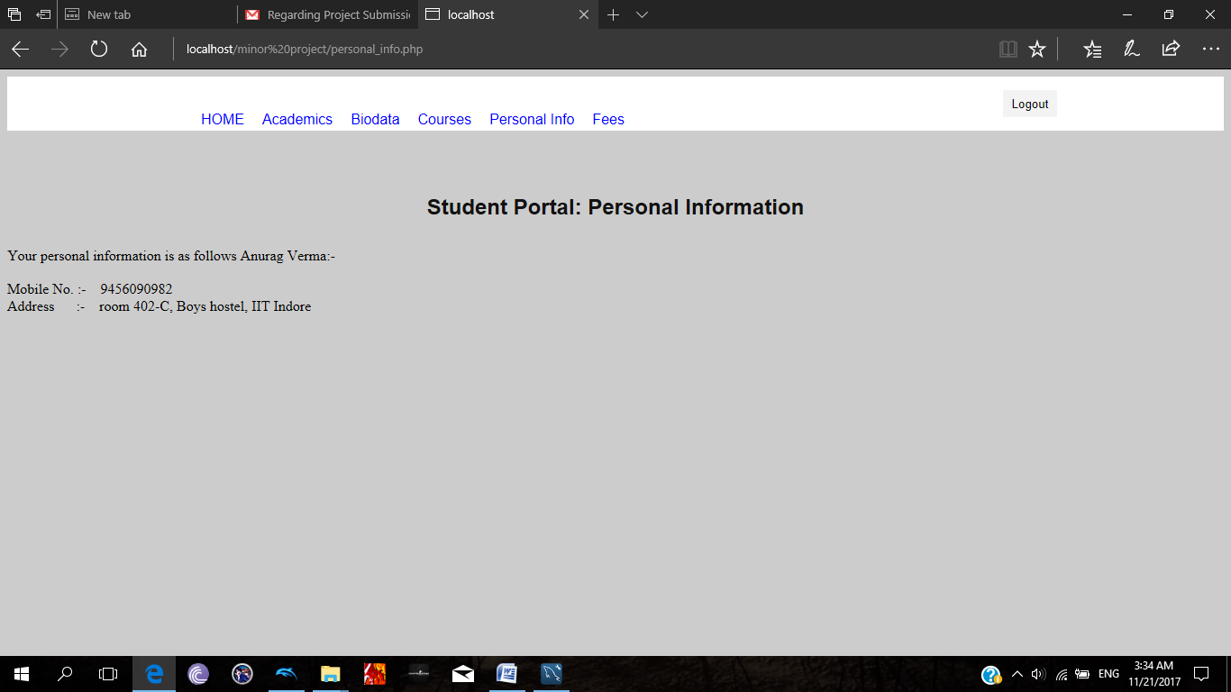

1. Viewing Money Transactions made:

The students can see all the college related money transactions they have made along with the amount, date, time, method here. If this record is not updated within 24 hrs of confirmation of transaction contact the college administration asap.

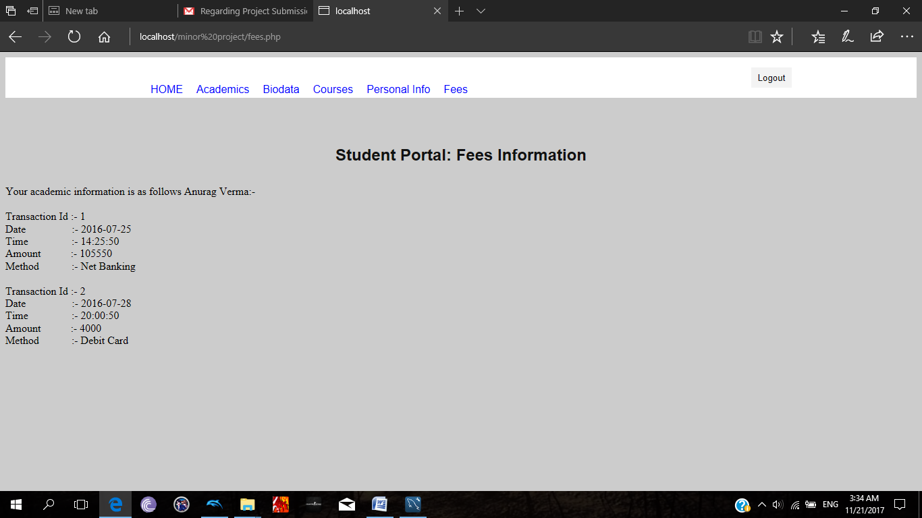

-Thank You-